DATA SCIENCE
PROJECT REPORT
(Project Semester January-April 2025)
Accident Data Analysis

Submitted by
Amit Krishna
Registration No: 12326830

Programme and Section: B-Tech KM005
Course Code: INT 217

Under the Guidance of
Baljinder Kaur 27952

Discipline of CSE
Lovely School of Computer Science and Engineering
Lovely Professional University, Phagwara

CERTIFICATE

This is to certify that Amit Krishna bearing Registration no. 12326830 has completed the INT217 project titled Accident Data Analysis under my guidance and supervision. To the best of my knowledge, the present work is the result of his original development, effort, and study.

Signature and Name of the Supervisor
Baljinder Kaur 27952

Designation of the Supervisor
School of Computer Science and Engineering
Lovely Professional University
Phagwara, Punjab.

Date: 8-04-2025

DECLARATION

I, Amit Krishna, a student of B.Tech under CSE/IT Discipline at Lovely Professional University, Punjab, declare that all the information furnished in this project report is genuine and based on my intensive work.

Date: 8-04-2025 Signature
Registration No. 12326830 Amit Krishna

1. INTRODUCTION
This project involves performing exploratory data analysis (EDA) and creating an interactive dashboard based on the vehicle crash data from New York City. The primary goal is to derive meaningful insights from crash data using Excel tools like Pivot Tables and Pivot Charts, which can assist in better decision-making and safety analysis.
Link to my LinkedIn: https://tinyurl.com/DashBoardEDA

2. SOURCE OF DATASET
The dataset is sourced from the NYC Open Data portal, containing crash data collected by the New York Police Department (NYPD). It includes fields like crash date, location, injuries, fatalities, contributing factors, and vehicle types involved in the incidents.
Link: https://catalog.data.gov/dataset/motor-vehicle-collisions-crashes

3. DATASET PREPROCESSING
- Missing values in numeric columns were filled using the mean.
- Missing values in categorical columns were filled using the mode.
- No rows were deleted.
- Crash Date Formatted using =Text()
- Additional columns created:
- CRASH_YEAR_MONTH from CRASH DATE
- CRASH_HOUR from CRASH TIME
- TOTAL_INJURED = PERSONS + PEDESTRIANS INJURED
- TOTAL_KILLED = PERSONS + PEDESTRIANS KILLED
- CRASH_SEVERITY = "Severe" if any injury/fatality, otherwise "Non-Severe"
- DAY_TYPE = Weekday or Weekend using WEEKDAY formula
- MONTHS=IFERROR(TEXT([@[CRASH DATE]],"mmm"),"")

4. ANALYSIS OF THE DATASET

Objective 1: Assess Accident Severity Levels
- Description: Understand the frequency of Severe vs Non-Severe crashes
- Requirements: CRASH_SEVERITY, COLLISION_ID
- Result: Two-thirds of the accidents that occurred were non-lethal, while rest of them had people either injured or killed.
- Visualization: Donut Pie Chart
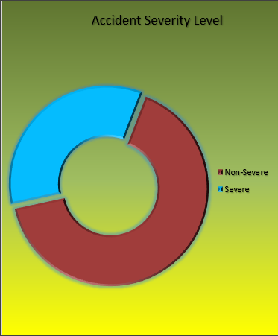

Objective 2: Identify High-Risk Locations
- Description: Streets with the most crashes
- Requirements: ON STREET NAME, COLLISION_ID
- Result: Belt parkway is the most risky location, with three-fourths of the accidents happening
- Visualization: Pie Chart
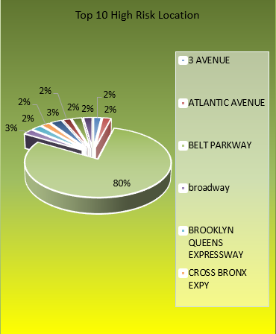

Objective 3: Examine Contributing Factors
- Description: Analyze crash causes
- Requirements: CONTRIBUTING FACTOR VEHICLE 1, COLLISION_ID
- Result: Distraction is the biggest reason for the accidents with other coming nowhere close.
- Visualization: Bar Chart
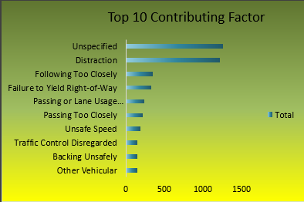

Objective 4: Evaluate Vehicle Involvement
- Description: Identify vehicles most involved
- Requirements: VEHICLE TYPE CODE 1 and 2, COLLISION_ID
- Result: Most accidents involve Sedan, with Station Wagon coming close next.
- Visualization: Column Chart
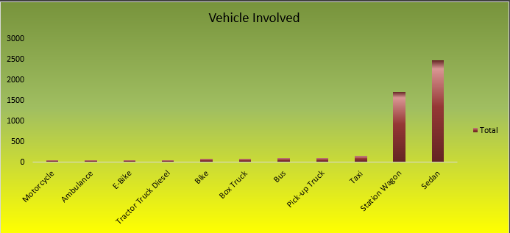

Objective 5: Casualty and Fatality Rates
- Description: Track injuries and deaths over time
- Requirements: CRASH DATE, TOTAL_INJURED, TOTAL_KILLED
- Result: There is a spike in accidents from March to May. There is also a little rise and fall in accidents from August to October, with accidents again seeing the trend of increasing from November and December.
- Visualization: Combo Line Chart
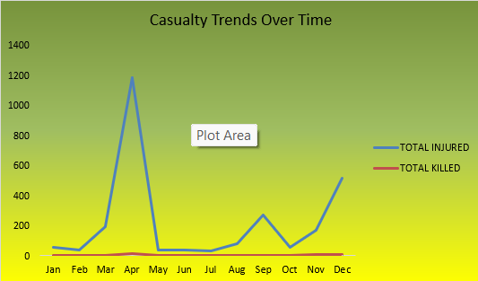

Objective 6: Correlate Contributing Factors with Accident Severity
- Description: See how causes relate to severity
- Requirements: CONTRIBUTING FACTOR VEHICLE 1, CRASH_SEVERITY, COLLISION_ID
- Result: Although Distraction has the most accidents however its severe-to-non-severe accidents are not as bad as Failure to Yield Right-of-Way, with almost a 6:4 severe-to-non-severe ratio.
- Visualization: Stacked Column
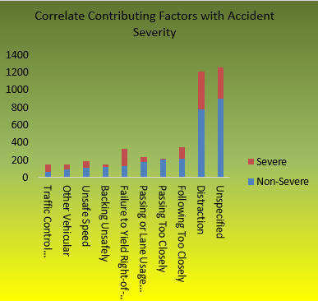

Objective 7: Weekend vs Weekday Accident Profiles
- Description: Compare trends by day type
- Requirements: DAY_TYPE, COLLISION_ID, TOTAL_INJURED, TOTAL_KILLED
- Result: More accidents occur during weekdays than on weekends. With the increase in accidents, there is also an increase in injuries and deaths.
- Visualization: Clustered Column Chart
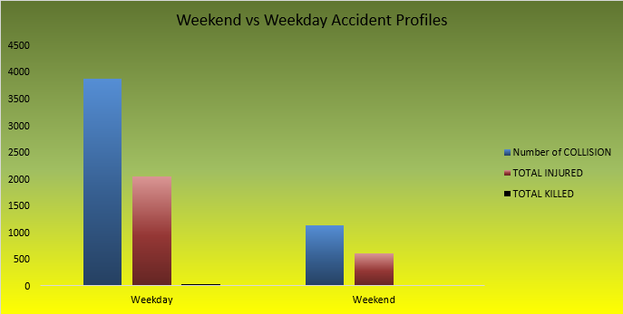

5. CONCLUSION
The analysis identified key risk factors in NYC traffic accidents. Factors like vehicle type, time, and location influence crash frequency and severity. Interactive dashboards make it easier to filter and analyse this data dynamically.

6. FUTURE SCOPE
- Apply clustering techniques to group high-risk zones
Explanation: Clustering involves using algorithms to automatically group similar data points together. In your context, it means analyzing your data (e.g., number of incidents, severity, location) to identify geographical areas that have similar risk profiles. Instead of manually defining high-risk zones, the algorithm does it for you, potentially uncovering patterns you might have missed.
- Integrate real-time data and alerts
Explanation: Real-time data integration means automatically updating your dashboard with the latest information as it becomes available. Alerts are notifications triggered when certain conditions are met (e.g., a spike in incidents in a specific area).
- Use Power BI for advanced visualizations
Explanation: Power BI is a data visualization and business intelligence tool that excels at creating interactive dashboards. It offers far more sophisticated charting options, data modeling capabilities, and data connectivity features than Excel.
- Include weather and traffic condition data
Explanation: Integrating weather and traffic data can help you understand how these factors influence risk. For example, incidents might be more likely to occur during periods of heavy rain or in areas with high traffic congestion.

7. REFERENCES
- NYC Open Data - Motor Vehicle Collisions, data.cityofnewyork.us
- Excel Official Documentation - support.microsoft.com
- Lovely Professional University Project Guidelines

